Most asked questions and answers
Virtual Thread?

Most asked questions and answers?

Q. ) Interface vs abstract class

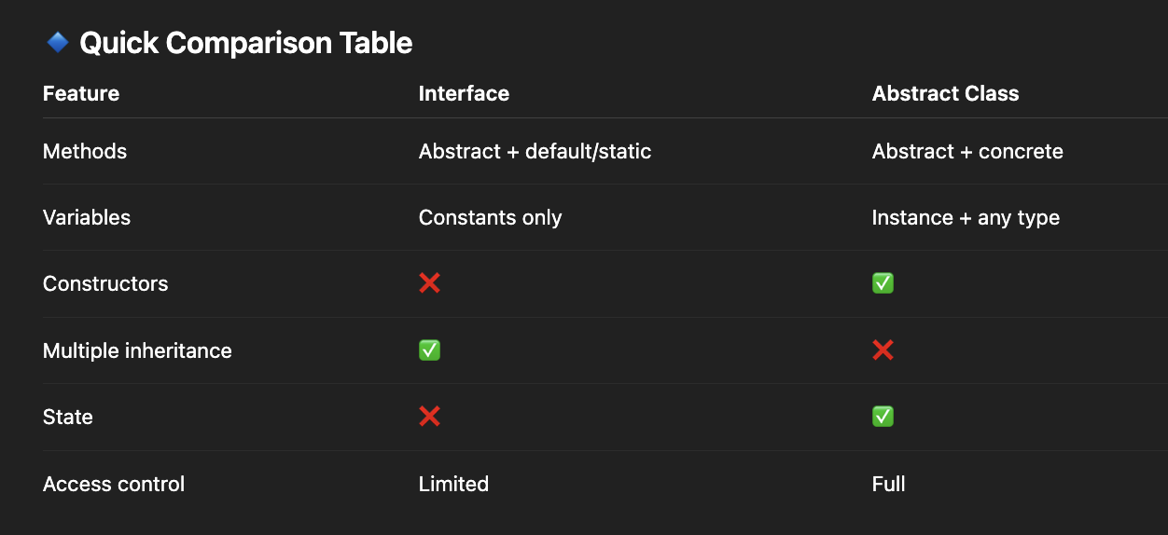

Use Interface when:
- You want multiple inheritance
- You define capability/behavior
- No shared state required
👉 Example:
interface Payment {
void pay();
}

Use Abstract Class when:
- You want code reuse
- You have common state + behavior
- You want controlled inheritance

abstract class Payment {
double amount;

abstract void pay();

void log() {
System.out.println("Payment initiated");
}
}

Q 2.) Contract between equals() and hashCode() in Java
Defined in Java Object class:

1. Consistency Rule
- If two objects are equal according to equals(), then their hashCode() must also be equal
if (a.equals(b)) {
a.hashCode() == b.hashCode(); // MUST be true
}

2. Non-Equality Rule
- If two objects have the same hashCode(),
they are NOT guaranteed to be equal
a.hashCode() == b.hashCode(); // does NOT mean a.equals(b)
👉 Because of hash collisions

3. Internal Consistency
- hashCode() must remain consistent as long as object state doesn’t change

4. Equals Consistency
- If you override equals(), you MUST override hashCode()

🔒 What are Immutable Classes?
An immutable class is a class whose objects cannot be changed after creation.
👉 Once the object is created, its state is fixed forever.
Examples in Java:
- String
- Integer
- LocalDate

✅ Characteristics of Immutable Classes
- No setters
- All fields are final
- Class is final (recommended)
- Fields are private
- Defensive copies for mutable objects
- State is initialized via constructor only

How to Create an Immutable Class

Example:
final class User {
private final int id;
private final String name;

public User(int id, String name) {
this.id = id;
this.name = name;
}

public int getId() {
return id;
}

public String getName() {
return name;
}
}

Handling Mutable Fields
final class Person {
private final Date dob;

public Person(Date dob) {
this.dob = new Date(dob.getTime()); // defensive copy
}

public Date getDob() {
return new Date(dob.getTime()); // return copy
}
}
Prevents external modification

If field itself is mutable:
Date
List
Map

Wrong Example
class Employee {
private final List<String> skills;

public List<String> getSkills() {
return skills;
}
}

Correct Way
public List<String> getSkills() {
return new ArrayList<>(skills);
}
And constructor also copies input:
this.skills = new ArrayList<>(skills);

Why Immutable?
- Thread-safe (no synchronization needed)
- Safe to share across threads
- Good for caching
- Predictable behavior

Why is String Immutable?
Ref: String

1. String Pool Optimization
- JVM maintains a pool of strings
- Same literals reuse memory
String a = "hello";
String b = "hello"; // same reference
👉 If mutable → one change affects all references ❌

2. Security
- Used in:
  - class loading
  - file paths
  - network connections
👉 If mutable → can be altered → security risk

3. Thread Safety
- No synchronization needed
- Safe sharing across threads

String, Stringbuffer and stringbuilder
Q .) What is the difference between String, StringBuilder, and StringBuffer?
- String → Immutable
- StringBuilder → Mutable, NOT thread-safe
- StringBuffer → Mutable, thread-safe

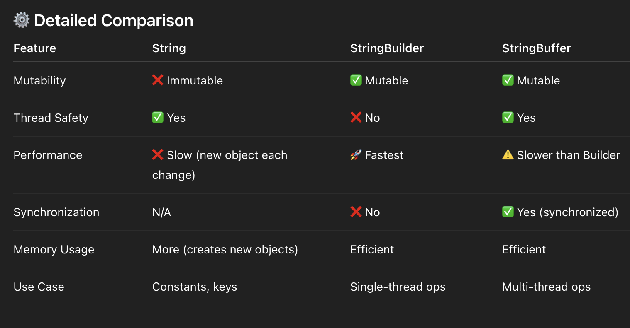

Performance Insight
- String → O(n²) in loops (due to repeated creation)
- StringBuilder → O(n)
- StringBuffer → Slightly slower than Builder (locking overhead)

🎯 When to Use What?

✅ Use String
- When value won’t change
- Constants / keys in HashMap
- String literals (benefit from pool)

✅ Use StringBuilder
- Default choice for string manipulation
- Single-threaded environment
- Performance-critical code

✅ Use StringBuffer
- Multi-threaded environment where shared mutation happens
- Rare in modern code (usually replaced by Builder + external sync)

Pass By Value

Q .) What is pass-by-value in Java?
When you pass a variable to a method, Java passes a copy of its value, not the original variable itself.

Java is always pass-by-value — no exceptions.
But the “value” differs:
- For primitives → actual value (int, double, etc.)
- For objects → reference value (address) is copied

Q .) What happens when you pass an object to a method in Java?
Ans.)
In Java, everything is passed by value.
When you pass an object, the value of its reference is passed (copy of reference).

What actually happens?
When you pass an object:
- A copy of the reference is passed to the method
- Both original and copied reference point to the same object in heap

class User {
int id;
}

void update(User u) {
u.id = 10;
}

User user = new User();
user.id = 5;

update(user);
System.out.println(user.id); // ?

Output: 10

Why?
- Both user and u refer to the same object
- So modifying object state reflects outside

Important Case
void change(User u) {
u = new User(); // new object
u.id = 20;
}
👉 Original object is NOT affected

Why?
- Only the reference copy is changed
- Original reference still points to old object

Cloning
Q .) What is object cloning? Shallow vs deep copy?
Ans.)
Object cloning means creating a new object with the same state as an existing object.
In Java, cloning is typically done using:
- Cloneable
- Object.clone() method

class User implements Cloneable {
int id;

public User(int id) {
this.id = id;
}

@Override
protected Object clone() throws CloneNotSupportedException {
return super.clone();
}
}

User u1 = new User(1);
User u2 = (User) u1.clone();

Important Notes
- clone() is protected in Object → must override
- Must implement Cloneable else → CloneNotSupportedException
- Cloning is considered tricky / not preferred in modern Java

🔄 Shallow Copy vs Deep Copy

🟡 1. Shallow Copy
Copies object, but references inside are shared

Example:
class Address {
String city;
}

class User implements Cloneable {
int id;
Address address;

@Override
protected Object clone() throws CloneNotSupportedException {
return super.clone(); // shallow copy
}
}

Memory View:
u1 ──► User ──► Address("Delhi")
u2 ──► User ──┘
👉 Both point to same Address object

❌ Problem
u2.address.city = "Mumbai";
System.out.println(u1.address.city); // Mumbai ❗
👉 Side effects!

🟢 2. Deep Copy
Copies object AND all nested objects

Example:
class User implements Cloneable {
int id;
Address address;

@Override
protected Object clone() throws CloneNotSupportedException {
User cloned = (User) super.clone();
cloned.address = new Address();
cloned.address.city = this.address.city;
return cloned;
}
}

Memory View:
u1 ──► User ──► Address("Delhi")
u2 ──► User ──► Address("Delhi")
👉 Completely independent objects

Marker Interfaces in Java

🔑 What are Marker Interfaces in Java?
A marker interface is an empty interface (no methods) used to “mark” a class.
This mark tells the JVM or frameworks:
“Apply special behavior to this class.”

🧠 Key Idea
- No methods
- No implementation
- Just a tag / signal

📦 Examples (Very Important)
- Serializable → allows object serialization
- Cloneable → allows object cloning
- RandomAccess → indicates fast random access (used by collections)

⚙️ How it Works Internally
Java checks marker interface using:
if (obj instanceof Serializable) {
// allow serialization
}
👉 Behavior changes based on presence of interface

📌 Example
class User implements Serializable {
int id;
}
👉 Now this object can be serialized
If NOT:
class User {
int id;
}
👉 Trying to serialize → ❌ Exception

🎯 Why Use Marker Interfaces?
- Provide metadata to JVM/frameworks
- Enable special processing
- Avoid adding unnecessary methods

Externalizable vs Serializable
What is Externalizable vs Serializable?

Both are used for object serialization in Java, but they differ in who controls the process.
- Serializable → JVM handles serialization automatically
- Externalizable → You fully control serialization

Core Idea
Both are used for object serialization in Java, but they differ in who controls the process.
- Serializable → JVM handles serialization automatically
- Externalizable → You fully control serialization

Serializable

✔️ How it works
- Marker interface (no methods)
- JVM serializes all non-transient, non-static fields automatically
class User implements Serializable {
int id;
String name;
}
No need to write serialization logic

Customization (optional)
private void writeObject(ObjectOutputStream oos)
private void readObject(ObjectInputStream ois)
Partial control if needed

Externalizable (Full Control)

✔️ How it works
- Extends Serializable
- You must override methods
class User implements Externalizable {
int id;
String name;

public User() {} // mandatory

@Override
public void writeExternal(ObjectOutput out) throws IOException {
out.writeInt(id);
out.writeObject(name);
}

@Override
public void readExternal(ObjectInput in) throws IOException, ClassNotFoundException {
id = in.readInt();
name = (String) in.readObject();
}
}
You decide:
- What to serialize
- How to serialize

ArrayList and LinkedList
Difference between ArrayList and LinkedList?

🔑 Core Difference
- ArrayList → Dynamic array (contiguous memory)
- LinkedList → Doubly linked list (nodes with pointers)

⚙️ Detailed Comparison
Feature | ArrayList | LinkedList
Internal structure | Dynamic array | Doubly linked list
Access by index | 🚀 O(1) | ❌ O(n)
Insert/delete (middle) | ❌ O(n) (shift needed) | ✅ O(1) (after traversal)
Memory | Efficient | Extra memory (prev/next pointers)
Cache locality | ✅ Good | ❌ Poor
Iteration | Faster | Slower
Implements | List | List + Deque

Internal Working

ArrayList
- Backed by resizable array
- When full → creates new array (~1.5x) and copies elements
list.add(10); // may trigger resize + copy

LinkedList
- Each node:
[prev | data | next]
- No shifting required for insert/delete
- But traversal required to reach position

📦 Example Differences

Access
list.get(5000);
- ArrayList → fast
- LinkedList → slow (traverse)

Insert in middle
list.add(2, 100);
- ArrayList → shift elements ❌
- LinkedList → pointer update ✅ (but traversal cost exists)

⚡ Performance Insight (Important)
- ArrayList is almost always preferred
- LinkedList rarely used in real-world systems
👉 Because:
- CPU cache favors arrays
- Linked list pointer chasing is slow

🎯 When to Use What?

✅ Use ArrayList (default choice)
- Frequent reads
- Index-based access
- Most real-world scenarios

✅ Use LinkedList (rare cases)
- Frequent insert/delete at head/tail
- Implementing queue/deque

🔥 Interview Trap
👉 “LinkedList insertion is O(1), so it’s faster, right?”
❌ Not always
- You still need O(n) traversal to reach position

How does HashMap work internally
How does HashMap work internally?

High-level idea
HashMap stores data as key → value using:
- Array of buckets
- Each bucket holds entries via:
  - Linked list (earlier / small collisions)
  - Balanced tree (Red-Black Tree) when collisions grow

⚙️ Core Flow (Put & Get)

🔹 put(key, value)
- Compute hash:
int hash = key.hashCode();
- Find bucket index:
index = hash & (n - 1); // n = capacity
- Insert:
- If bucket empty → add node
- If same key exists → update value
- If collision → add to chain (list/tree)

🔹 get(key)
- Compute hash
- Go to bucket
- Traverse:
  - Linked list → linear search
  - Tree → log(n) search

🧠 Internal Structure
Each entry is like:
class Node<K,V> {
int hash;
K key;
V value;
Node<K,V> next;
}

🔥 Collision Handling

Case 1: Few collisions
Bucket → [Node] → [Node] → [Node]

Case 2: Many collisions (Java 8+)
Bucket → Red-Black Tree
👉 Trigger:
- Bucket size > 8 → treeify
- Bucket size < 6 → back to list

⚡ Time Complexity
Operation | Average | Worst
put() | O(1) | O(log n)
get() | O(1) | O(log n)

🔄 Resizing (Very Important)
- Default capacity = 16
- Load factor = 0.75
👉 Resize when:
size > capacity * loadFactor

What happens?
- Capacity doubles
- All elements rehash & redistribute

🎯 Why hash & (n-1)?
index = hash & (n - 1);
👉 Faster than modulo (%)
👉 Works because capacity is power of 2

⚠️ Interview Traps

1. Mutable keys ❌
map.put(user, value);
user.id = 10; // breaks retrieval

2. equals() & hashCode() contract
If violated → incorrect behavior

3. Null handling
- 1 null key allowed
- Multiple null values allowed

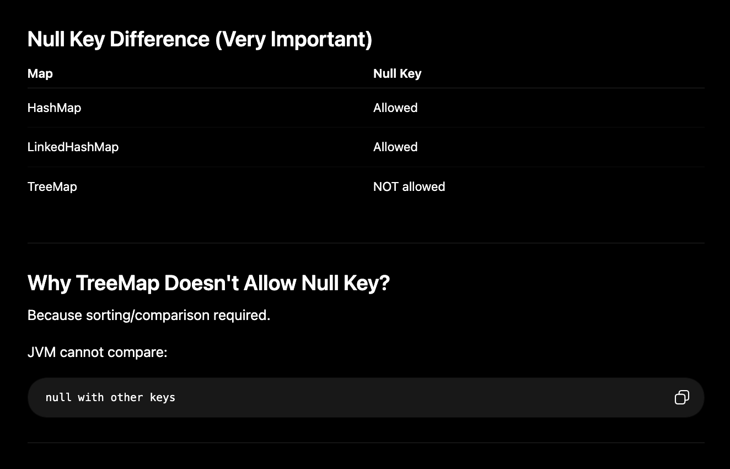

Internal Logic (Simplified)
if (key == null)
return 0;
else
return key.hashCode();

Meaning
All null keys get:
hash = 0
and are stored in bucket 0.

Why hashmap not thread safe
Q.) Why is HashMap not thread-safe?

HashMap is not thread-safe because it has no synchronization, so concurrent reads/writes can lead to data corruption, lost updates, and inconsistent state.

🧠 What goes wrong internally?

1. ❌ Race conditions (lost updates)
map.put("A", 1); // Thread 1
map.put("A", 2); // Thread 2
👉 Final value depends on timing → non-deterministic

2. ❌ Corruption during resize (rehashing)
When size exceeds threshold:
- Map resizes
- Buckets are rehashed
👉 If multiple threads resize together:
- Entries may be misplaced
- Structure can become inconsistent

3. ❌ Infinite loop issue (classic problem)
In older Java versions (pre-Java 8):
- During concurrent rehashing
- Linked list could become a cycle
A → B → C → A (loop)
👉 Any get() → infinite loop / CPU spike

4. ❌ Visibility issues (Memory model)
- One thread updates map
- Other thread may not see updated value
👉 Due to lack of happens-before relationship

5. ❌ Structural inconsistency
- Partial updates:
  - Key added but value missing
  - Node linked incorrectly
👉 Leads to unpredictable behavior

Hashing
Q.) What is hashing and hash collision?

What is Hashing?
Hashing is the process of converting data (key) into a fixed-size integer value (hash code) using a hash function.
In Java, this is done via:
key.hashCode();
Used heavily in:
- HashMap
- HashSet

Why hashing?
To enable fast data access (O(1))
Instead of searching linearly:
- Compute hash → directly jump to bucket

Example
String key = "apple";
int hash = key.hashCode();
👉 This hash determines where the key-value pair is stored

⚙️ How Hashing Works (in simple terms)
- Take key
- Apply hash function → get number
- Map that number to an index (bucket)
index = hash & (capacity - 1);

💥 What is Hash Collision?
When two different keys produce the same hash/index

📦 Example
"FB".hashCode() == "Ea".hashCode()
👉 Both go to same bucket

🔍 Collision in HashMap
Bucket:
[FB → 1] → [Ea → 2]
👉 Multiple entries in same bucket

⚙️ How Java Handles Collisions
In HashMap:

1. Linked List (default)
- Store entries in chain

2. Red-Black Tree (Java 8+)
- If bucket size > 8 → convert to tree
- Improves performance to O(log n)

⚡ Why collisions are unavoidable?
- Infinite possible keys
- Finite number of buckets
👉 So collisions are guaranteed

🚨 Impact of Bad Hashing
If many collisions:
All keys → same bucket
👉 Performance becomes:
- O(n) instead of O(1)

🎯 Good Hash Function Properties
- Uniform distribution
- Fast computation
- Deterministic (same input → same output)

Rehashing

What is Rehashing?
Rehashing is the process of:
- Increasing capacity (usually doubling)
- Recomputing bucket index for all existing entries
- Redistributing them into new buckets

Example Flow

Before resize:
Capacity = 16
Threshold = 12
Size = 12 → OK
Insert 13th element:
👉 Trigger rehashing

After resize:
Capacity = 32
Threshold = 32 × 0.75 = 24
👉 All elements moved to new buckets

Why rehashing is needed?
Because bucket index depends on capacity:
index = hash & (capacity - 1);
👉 When capacity changes → index changes
👉 Must recompute positions

⚡ Performance Impact
- Rehashing is expensive (O(n))
- Happens occasionally
- Amortized cost still ~O(1)

Interview Insights

1. Rehashing is costly
Avoid frequent resizing by setting initial capacity
new HashMap<>(1000);

2. Not thread-safe
- Concurrent resize → issues (pre-Java 8 infinite loop bug)

3. Doubling capacity matters
- Keeps capacity power of 2 → faster index calculation

ConcurrentHashMap and how does it work
Q .) What is ConcurrentHashMap and how does it work?
What is ConcurrentHashMap and how does it work?

🔑 What is ConcurrentHashMap?
ConcurrentHashMap is a thread-safe, high-performance map designed for concurrent access.
It allows multiple threads to read and write simultaneously without locking the entire map.

🧠 Why not use HashMap or synchronized map?
- HashMap → ❌ not thread-safe
- Collections.synchronizedMap() → ❌ locks whole map (slow)
👉 ConcurrentHashMap = thread safety + performance

⚙️ How it Works (Java 8+)

🔹 1. No global lock
Instead of locking the whole map:
- Locks only the bucket (bin) being modified
👉 Fine-grained locking

🔹 2. Data structure
Similar to HashMap:
- Array of buckets
- Each bucket contains:
  - Linked list OR
  - Red-Black Tree (if collisions > threshold)

🔹 3. CAS (Compare-And-Swap)
Uses low-level atomic operations:
- For insertion (if bucket empty):
  - No lock needed
  - Uses CAS to insert safely
👉 Faster than synchronized

🔹 4. Locking only when needed
- Read (get) → NO LOCK ✅
- Write (put) → lock only that bucket

📦 Operation Flow

🔸 get(key) (Non-blocking)
map.get("A");
- Compute hash
- Find bucket
- Traverse → return value
👉 No locking → very fast

🔸 put(key, value)
map.put("A", 1);
- Compute hash
- If bucket empty → CAS insert
- If collision → lock that bucket → insert/update

⚡ Key Features
Feature | Behavior
Thread safety | ✅ Yes
Read performance | 🚀 Very fast (lock-free)
Write locking | Fine-grained
Null keys/values | ❌ Not allowed
Iteration | Weakly consistent

🔥 Important Differences from HashMap
Feature | HashMap | ConcurrentHashMap
Thread-safe | ❌ | ✅
Locking | None | Bucket-level
Null keys | ✅ 1 allowed | ❌ Not allowed
Performance | Fast (single thread) | Fast (multi-thread)

⚠️ Interview-Level Insights

1. Why no null allowed?
👉 To avoid ambiguity:
map.get(key) == null
- Key absent OR value null? ❌ unclear

2. Weakly consistent iterator
- No ConcurrentModificationException
- Reflects some updates, not all

3. Java 7 vs Java 8 difference
- Java 7 → Segment-based locking
- Java 8 → Bucket-level + CAS (better)

🔑 What is CAS

🔑 What is CAS?
CAS (Compare-And-Swap) is a low-level atomic operation used in concurrent programming.
It updates a value only if it matches an expected value — otherwise, it fails and retries.

⚙️ CAS Operation (Core Idea)
CAS(variable, expectedValue, newValue)
👉 Steps:
- Check if variable == expectedValue
- If yes → update to newValue ✅
- If no → do nothing ❌ (retry)

📦 Example
AtomicInteger count = new AtomicInteger(0);

// internally uses CAS
count.incrementAndGet();
Behind the scenes:
read current value → compare → update if same → retry if failed

🧠 Why CAS is powerful?
- No locks (lock-free)
- Avoids thread blocking
- High performance in multi-threaded systems
Used in:
- ConcurrentHashMap
- AtomicInteger

🔄 How CAS Works (Step-by-step)
Assume:
variable = 10;
Thread T1:
expected = 10
newValue = 20
Thread T2:
expected = 10
newValue = 30

Execution:
- T1 → sees 10 → updates to 20 ✅
- T2 → sees 20 (not 10) → fails ❌ → retries

🔁 Retry Loop (Important)
CAS is usually used with a loop:
AtomicInteger count = new AtomicInteger(0);
//count.incrementAndGet();
while (true) {
int current = count.get();
int next = current + 1;
if (count.compareAndSet(current, next)) {
break;
}
}
👉 Retry until success

fail-fast and fail-safe
Q .) Difference between fail-fast and fail-safe iterators?
ans.)
Core Difference
- Fail-fast iterators → throw exception if collection is modified during iteration
- Fail-safe iterators → work on a copy, so no exception

Fail-Fast Iterator
Used by:
- ArrayList
- HashMap

🧠 How it works
- Each collection maintains a modCount
- Iterator stores expectedModCount
- On each operation → checks:
if (modCount != expectedModCount)
throw new ConcurrentModificationException();

📦 Example
List<Integer> list = new ArrayList<>();
list.add(1);
list.add(2);

for (Integer i : list) {
list.add(3); // ❌ modification
}
👉 Throws:
ConcurrentModificationException

⚙️ Fail-Safe Iterator
Used by:
- ConcurrentHashMap
- CopyOnWriteArrayList

🧠 How it works
- Iterates over a snapshot (copy) of collection
- Original collection can change safely

📦 Example
CopyOnWriteArrayList<Integer> list = new CopyOnWriteArrayList<>();
list.add(1);
list.add(2);

for (Integer i : list) {
list.add(3); // ✅ no exception
}

Comparable and Comparator
Q. ) Difference between Comparable and Comparator?

Core Difference
- Comparable → defines natural ordering (inside the class)
- Comparator → defines custom ordering (outside the class)

⚙️ Comparable (Natural Ordering)

✔️ Defined inside the class
class User implements Comparable<User> {
int age;

@Override
public int compareTo(User other) {
return this.age - other.age;
}
}
👉 Default sorting logic

📦 Usage
Collections.sort(userList);

⚙️ Comparator (Custom Ordering)

✔️ Defined outside the class
class AgeComparator implements Comparator<User> {
@Override
public int compare(User a, User b) {
return a.age - b.age;
}
}

📦 Usage
Collections.sort(userList, new AgeComparator());

Differences:

Feature | Comparable | Comparator
Package | java.lang | java.util
Method | compareTo() | compare()
Defined | Inside class | Outside class
Flexibility | ❌ Single logic | ✅ Multiple logics
Use case | Natural/default sorting | Custom sorting

🧠 Real Example

Comparable → sort by age

Comparator → sort by:
- name
- salary
- multiple fields

🔥 Java 8+ (Lambda Comparator)
Collections.sort(list, (a, b) -> a.age - b.age);

⚠️ Interview Traps

1. Multiple sorting logic?
👉 Use Comparator

2. Modifying existing class not allowed?
👉 Use Comparator

3. TreeSet / TreeMap behavior
- Uses:
  - Comparable OR
  - Comparator

How does sorting work internally in Java

How does sorting work internally in Java?

🔑 Short Answer
Java uses TimSort for sorting objects and Dual-Pivot QuickSort for primitives.

Which algorithm is used where?

1. Objects (List, arrays of objects)
- Collections.sort()
- Arrays.sort(Object[])
👉 Uses TimSort

2. Primitives (int, double, etc.)
- Arrays.sort(int[])
👉 Uses Dual-Pivot QuickSort

1. TimSort (for Objects)
Used in:
- Collections
- Arrays

🔹 What is TimSort?
Hybrid of:
- Merge Sort
- Insertion Sort

🔹 Key Idea
- Identify already sorted parts (runs)
- Sort small chunks using insertion sort
- Merge them efficiently

📦 Why TimSort?
- Optimized for real-world data
- Works great if data is partially sorted

⚡ Complexity
Case | Time
Best | O(n)
Average | O(n log n)
Worst | O(n log n)

✅ Stable Sort
👉 Maintains order of equal elements

⚙️ 2. Dual-Pivot QuickSort (for primitives)

🔹 How it works?
- Uses two pivots instead of one
- Partitions array into 3 parts:
  - less than pivot1
  - between pivots
  - greater than pivot2

⚡ Complexity
Case | Time
Average | O(n log n)
Worst | O(n²)

❌ Not Stable

Tab 17

Intern()?
intern() is a method of the Java Platform String class.
It is used to store/retrieve strings from the String Constant Pool (SCP).

Using intern()
String s1 = new String("hello");
String s2 = s1.intern();

String s3 = "hello";

System.out.println(s2 == s3);
Output:
true

What intern() Does Internally?

Internal Working
1. JVM checks String Pool
2. String already exists?
YES → return pooled reference
NO → add to pool and return reference

Case 3 — Using intern()
String a = new String("abc").intern();
String b = "abc";

System.out.println(a == b);
Output:
true

Q.) CopyonwritearrayList?

What Actually Happens Internally?
CopyOnWriteArrayList works like this:

On every write operation:
- create a NEW copy of internal array
- modify new array
- replace old reference atomically
Example:
list.add("A");
Internally:
oldArray -> copy -> modify -> replace reference

If Two Threads Write Simultaneously
Suppose:
Thread T1 -> add("A")
Thread T2 -> add("B")
Both cannot modify array simultaneously.
Because write methods are internally:
synchronized / lock protected
So:

One thread gets lock first
Example:
T1
It:
- copies array
- adds element
- replaces reference
- releases lock
Then: T2 does same process using latest array.

Interview-Friendly Summary
CopyOnWriteArrayList is thread-safe because every write operation creates a new copy of the underlying array. Multiple writes are synchronized internally, so only one thread writes at a time. Readers work on immutable snapshots, avoiding ConcurrentModificationException.

Tab 18
System.out.println

1. System
System is a class from java.lang package.
java.lang.System

It provides:
- Standard input/output
- Access to JVM
- Environment variables
- Time methods
- Garbage collection utilities

Important
- System class cannot be instantiated
- Most members are static

2. out
out is a static variable inside System class.
public static final PrintStream out;

Important Points
Keyword | Meaning
public | Accessible everywhere
static | Belongs to class
final | Cannot be reassigned
PrintStream | Type of object

3. println()
println() is a method of PrintStream class.
public void println(String x)
It:
- Prints data
- Moves cursor to next line

Why out is Static?
So that we can use it directly:
System.out.println()
without creating object of System.

String
Can immutable classes have mutable fields?

Yes, an immutable class can contain mutable fields, but only if the mutable objects are handled carefully so the class itself remains effectively immutable.

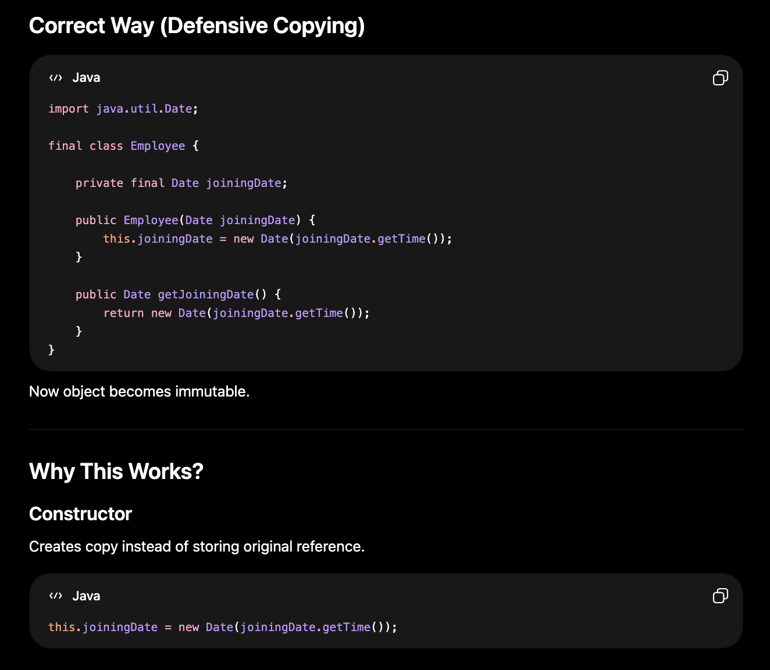

Why is String Final in Java?
Main Reasons Why String is Final:
1. Security
2. Immutability
3. String Pool Optimization
4. Thread Safety
5. Hashcode Caching
6. Performance

1. Security
Strings are heavily used in sensitive operations:
- Database URLs
- File paths
- Network connections
- Class loading
- Security credentials
If String were mutable/inheritable, attackers could modify behavior.

Tab 20
Q.) Throw vs Throws Excpetion?
Ans.) 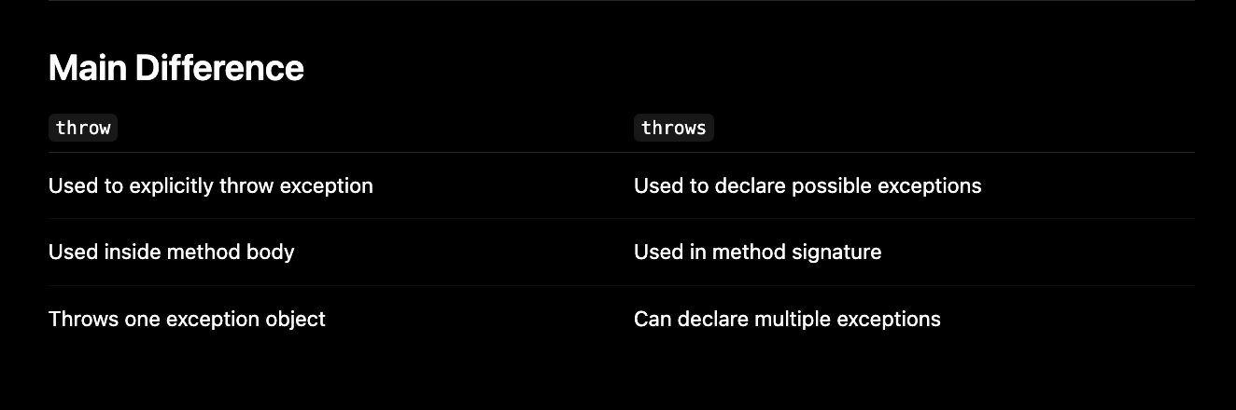

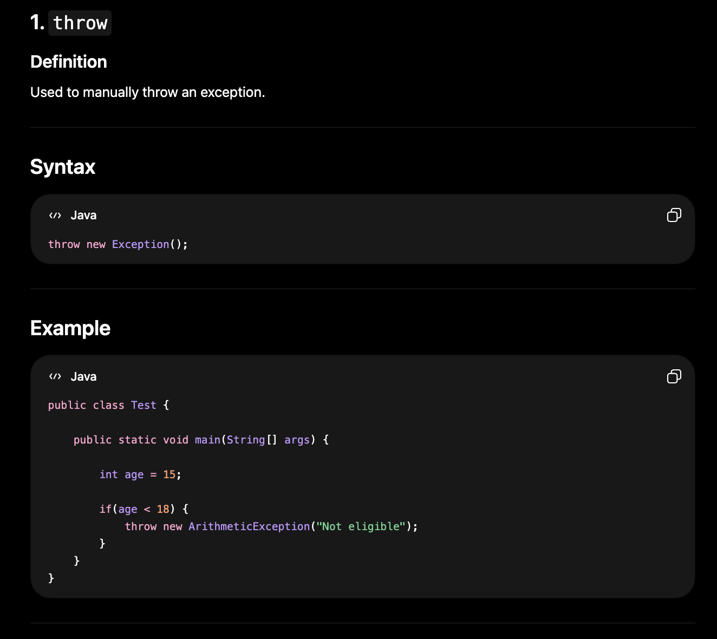

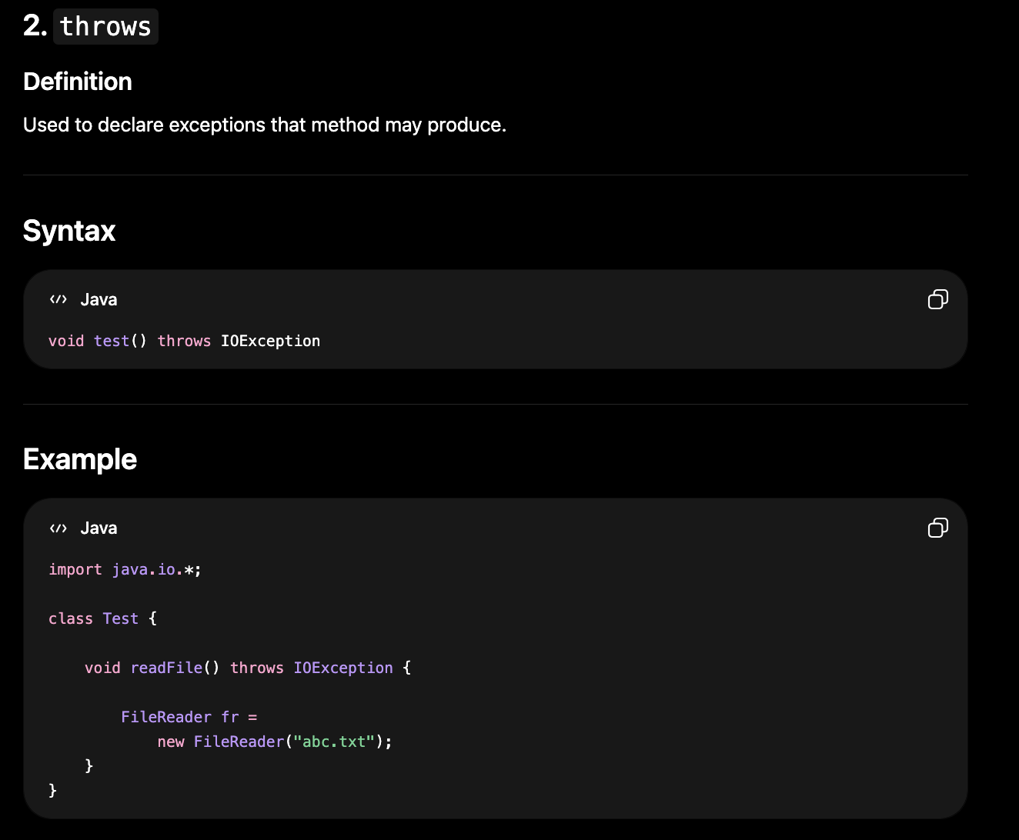

Q.) Will finally execute after return?
Ans.) 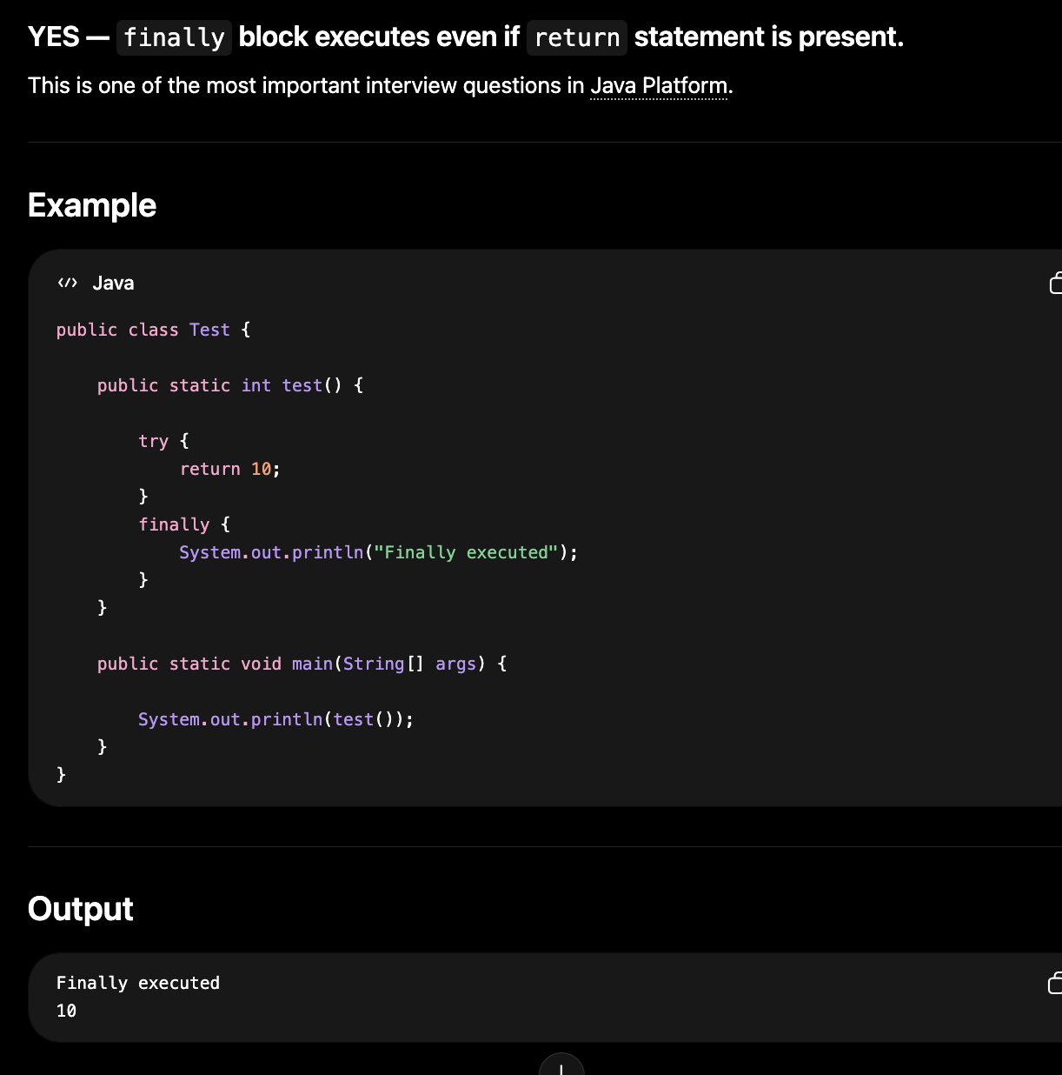

Q. ) What is try-with-resources?

Try-With-Resources in Java
Try-with-resources is a feature introduced in:
Java Platform
used for automatic resource management.

Purpose:
Automatically closes resources like:
- Files
- Streams
- Sockets
- Database connections
without needing explicit finally block.

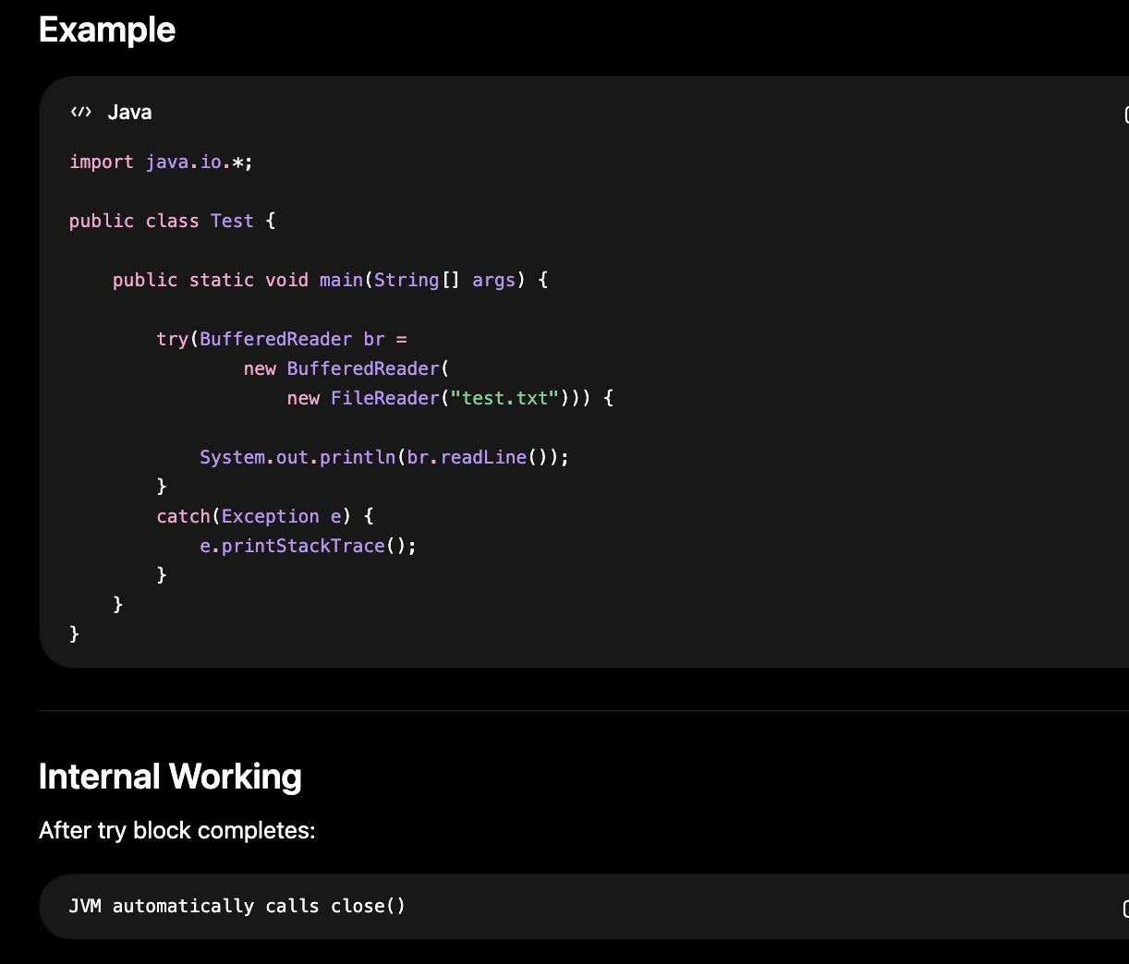

Tab 21
Q.) Why wait(), notify(), and notifyAll() are in Object Class?

Ans.) Every object in Java can act as a monitor/lock
and wait/notify work on monitors.
Since every class inherits from Object:
All objects automatically get monitor methods

Important Concept — Monitor
Every Java object has an intrinsic:
- Monitor
- Lock
- Mutex
associated with it.

Example
Object lock = new Object();

synchronized(lock) {

}
Here:
lock object acts as monitor

Why wait() Needs Object?
wait() means:
"Current thread releases THIS object's lock and waits"
So waiting is always related to a specific object monitor.

finalize() in Java
finalize() is a method of the Java Platform Object class.
It was historically used to perform cleanup before an object is garbage collected.

CompletableFuture
CompletableFuture

1. Creating CompletableFuture

CompletableFuture<String> future = CompletableFuture.supplyAsync(() -> "Hello");

CompletableFuture<Void> future =CompletableFuture.runAsync(() -> {
System.out.println("Task");
});

Difference
- supplyAsync() → returns a value.
- runAsync() → does not return a value (Void).

2. Transforming Result

thenApply()
CompletableFuture<String> future =CompletableFuture.supplyAsync(() -> "Java").thenApply(String::toUpperCase);

Output: JAVA

3. Consuming Result

thenAccept()

CompletableFuture.supplyAsync(() -> "Java").thenAccept(System.out::println);

Consumes result but returns nothing.

4. Execute After Completion

thenRun()
CompletableFuture.supplyAsync(() -> "Java").thenRun(() -> System.out.println("Done"));
No access to result.

5. Combining Futures

thenCombine()

CompletableFuture<String> f1 =
CompletableFuture.supplyAsync(() -> "Hello");

CompletableFuture<String> f2 =
CompletableFuture.supplyAsync(() -> " World");

CompletableFuture<String> result =
f1.thenCombine(f2, (a, b) -> a + b);

Output:
Hello World

6. Dependent Futures

thenCompose()

Used when second async task depends on first result.

CompletableFuture<String> future =CompletableFuture.supplyAsync(() -> "Java")
.thenCompose(s -> CompletableFuture.supplyAsync(() -> s + " 21"));

Interview Question
thenApply vs thenCompose
thenApply() -> Future<Future<T>>
thenCompose() -> Future<T>
thenCompose() flattens nested futures.

7. Waiting for Multiple Futures

allOf() : Wait for all tasks
CompletableFuture.allOf(f1, f2, f3).join();

anyOf() : Returns when any task completes.
CompletableFuture.anyOf(f1, f2, f3);

8. Exception Handling

exceptionally()

CompletableFuture<Integer> future =CompletableFuture.supplyAsync(() -> 10 / 0)
.exceptionally(ex -> -1);

Output:
-1

handle() : Can handle both success and failure.

future.handle((result, ex) -> {
if (ex != null)
return -1;
return result;
});

whenComplete()
Only observes.

future.whenComplete((result, ex) -> {
System.out.println(result);
});

Does not modify result.

9. join() vs get()

join()
future.join();
- Throws unchecked CompletionException.
- No checked exception handling.

get()
future.get();
- Throws checked exceptions:
  - InterruptedException
  - ExecutionException
Most modern code uses join().

10. Custom Thread Pool
Default: ForkJoinPool.commonPool()
Custom:
ExecutorService executor = Executors.newFixedThreadPool(10);

CompletableFuture.supplyAsync(
() -> "Java",
executor
);

Interviewers often ask:
Why use a custom Executor?
Answer:
- Better control over threads.
- Avoid overloading common pool.
- Separate CPU-intensive and IO-intensive tasks.

11. Async vs Non-Async Methods

Non Async
thenApply()
thenAccept()
thenRun()
May execute in the thread that completed the previous stage.

Async
thenApplyAsync()
thenAcceptAsync()
thenRunAsync()
Runs in another thread (common pool or provided executor).

12. Common Interview Question

Call 3 Microservices in Parallel

CompletableFuture<User> user =CompletableFuture.supplyAsync(this::getUser);
CompletableFuture<Order> order = CompletableFuture.supplyAsync(this::getOrders);
CompletableFuture<Payment> payment = CompletableFuture.supplyAsync(this::getPayments);
CompletableFuture.allOf(user, order, payment).join();

This reduces total response time because calls run concurrently.

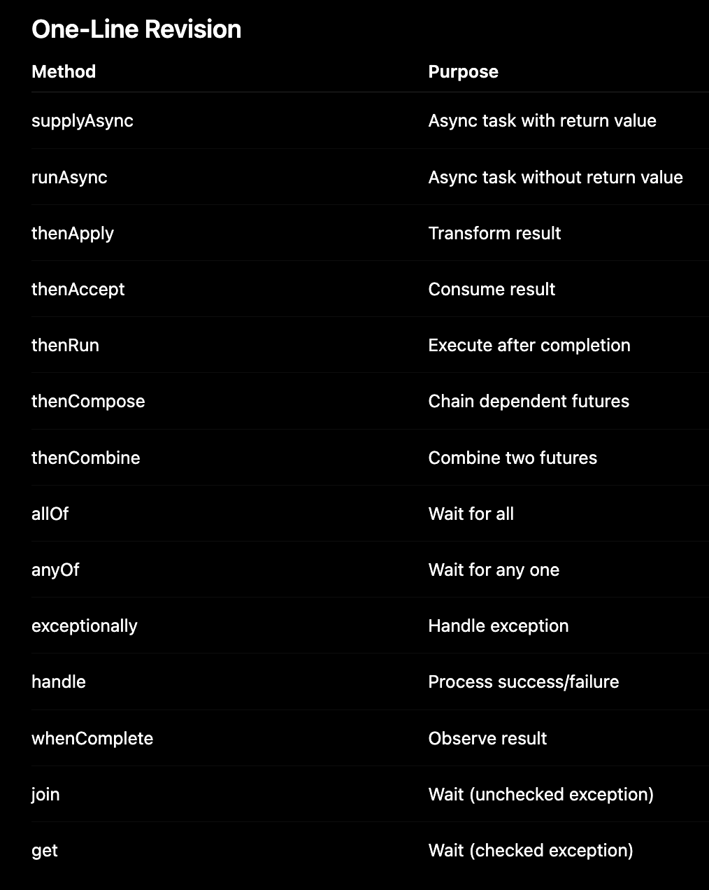

focus especially on:
- supplyAsync()
- thenApply()
- thenCompose()
- thenCombine()
- allOf()
- exceptionally()
- join() vs get()
- Custom ExecutorService
- Calling multiple microservices in parallel using CompletableFuture.

